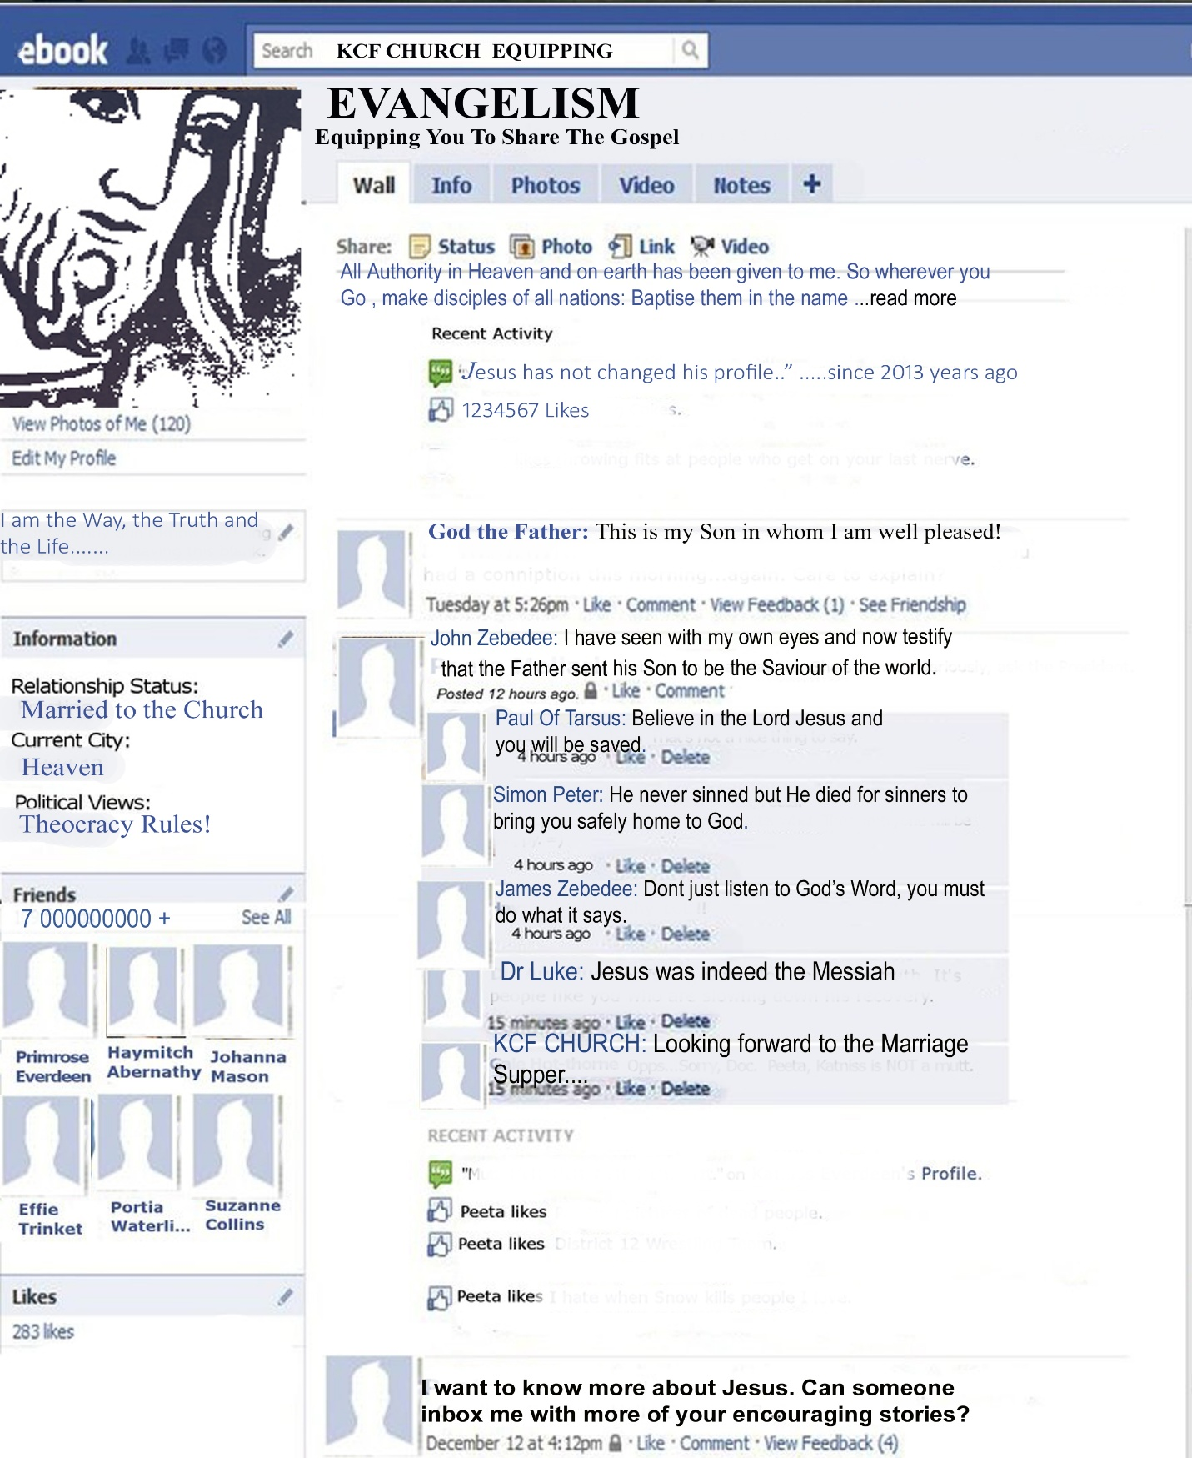
LCF CHURCH EQUIPPING



Content

Introduction 3
Types of Unbelievers 5
Looking At Your Oikos 8
The Man Of Peace 10
My Personal Testimony 11
John 3:16 Presentation 15
The Sinners Prayer 21
Getting Into An Unbeliever’s Home 21
Time For Practicals 23


Introduction

Our sole purpose on this earth is to win souls; to make disciples. Jesus said, “ All authority in heaven and on earth has been given to me. Therefore go and make disciples of all nations, baptising them in the name of the Father and of the Son and of the Holy Spirit, and teaching them to obey everything I have commanded you.” (Matthew 28:18-20)

How do we go about doing this?

Firstly through our lifestyle. We need live out Jesus to those around us.
This means we need a relationship with God, where we place Him first in everything. We need to die to self, our old way of life, and make Him Lord and Master of our lives, our money, and our possessions.

Secondly in our service to those around us. Isaiah 61:1- says we have been anointed to minister to the needs of the folk and this includes bringing them to a place of salvation.

“ This is how we know what love is: Jesus Christ laid down his life for us. And we ought to lay down our lives for our brothers.” 1 John 3:16

“ Dear children, let us not love with words or tongue but with actions and in truth.” 1John 3:18

Are you equipped to do this?

YES! If you have been baptised with the Holy Spirit, Acts 1:8 says, “ But you will receive power when the Holy Spirit comes on you;

and you will be my witnesses in Jerusalem, and in all Judea and
Samaria, and to the ends of the earth.”

In our Christian walk the Holy Spirit has many functions, the most important one being giving us power to present the good news to the lost.

Soul winners are wise.

In Daniel 12:3 it is stated that soul winners are wise “and those who turn many to righteousness shall shine like the stars for ever and ever.”
We are called wise stewards when we give spiritual food to others (Matthew 24:25). The Holy Spirit will give you wisdom when dealing with each person you encounter. (Luke 21:14-15)

A challenge to all disciples!

We know that time is running out for this earth and we as disciples have a responsibility to bring in the harvest.
- Who is going to preach the gospel?
- Who is going to tell the lost about Jesus?
We, as Christians, must take the Gospel of Jesus Christ into the entire world. We are not all called to go to distant lands to preach the Gospel to all nations and languages, but we are called to be witnesses to those around us. We are to take the Gospel to those that are perishing and without hope and to our families, friends and acquaintances.
Let the love of Jesus that has been shed abroad in our hearts drive and inspire us to be His witnesses to all around us.

Types of Unbelievers

This equipping station teaches you to bring searching unbelievers in your oikos to Christ. You will do this by partnering with another member of your Cell Group. Together, you will lead others to accept Christ as Lord and be nurtured in your group.
Every unbeliever we meet can be classified in one of the sections of this pyramid.
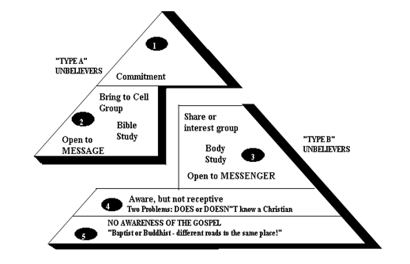
“TYPE A UNBELIEVERS: THE “LIKE US” PEOPLE, EASILY REACHED

- They are willing to attend a Celebration or a special cell group meeting, e.g. an Outreach evening or a Harvest Event.
- They already believe in God, accept the Bible, understand that Jesus is the Son of God, and have some awareness of scripture facts (like Christ’s death on the cross). They may already have a church membership somewhere, but are inactive – perhaps have been so for years. They are searching for something.
- They may not have all the information needed about Christ’s love for them.
- Bible Study or explaining the plan of Salvation are appropriate activities to do with them.

“TYPE B” UNBELIEVERS: UNREACHED PEOPLE, NEEDING CULTIVATION

- They have no interest in the Christian faith.
- They may not believe in God, do not accept the Bible, do not understand Jesus is the Son of God, and have little awareness of Scripture.
- They have no church membership.
- They are not searching for the Lord’s purpose in their lives, and have no intention of attending church activities.
- They have very few of the “pieces of the puzzle” in place as far as Christian knowledge is concerned.
- Bible Study or discussing the plan of Salvation aren’t appropriate activities to do with them at the start. There must first be a time of developing relationships – exposing them to the reality of the living Christ in our own lives.

Just like different raw materials are harvested in various ways, so too different people need to be led to Jesus in appropriate ways.

QUESTIONS:

At which of the pyramid levels would it be possible to: -
(You need only to write in the number of the level)

_____ Study the Bible together?

_____ Share your conversion testimony?

_____ Go on a biking or hiking excursion?

_____ Invite a friend to attend a Celebration?

_____ Invite a friend to pray to receive Christ?

_____ Spend time developing a friendship?

_____ Meet family members?

START AT HOME (Looking at your oikos)

What does ‘oikos’ mean?

This is Greek Word found in the New Testament of the Bible and it means “dwelling, house” – by implication, “family” (See Acts 16:31, Luke 19:9).
A person’s oikos can consist of family members as well as friends and working acquaintances, in fact anyone with whom we spend at least one hour or more a week.
It is noted that Christians tend to spend more time with other Christians, rather than penetrate the world of the unbelievers. The result is that unbelievers may never have the opportunity of hearing the Good News of the Gospel.
It is therefore vital that we as Christians establish oikos connections outside of our comfort zones and build bridges with unbelievers or we will never accomplish the task of saving the lost. Every cell must have strategies on how to penetrate and target unbelievers.

Reaching beyond our oikos!

There will come a time when we run out of oikos connections, then we must look to penetrate other oikoses linked to our oikos e.g. My sister or brother has an oikos and there are many unsaved in her/his circle and my dressmaker/ tailor has an oikos and with her/his help I can penetrate that circle. By doing this I can potentially touch at least another two hundred people by just extending beyond my present oikos. If we are sensitive to the Holy Spirit, He will guide us and open up people’s hearts and minds to receive the Good News.
Never forget that wherever you find yourself God has put you there for a purpose to proclaim the Good News of the Gospel to the lost.

List the unbelievers in your oikos and state whether they are TYPE A or TYPE B unbelievers.

OIKOS LIST

TYPE OF UNBELIEVER

1. _________________________________________________

2. _________________________________________________

3. _________________________________________________

4. _________________________________________________

5. _________________________________________________

6. _________________________________________________

7. _________________________________________________

Now that you have your oikos list and you know what type of unbeliever each person is, you can pray and strategise around how you can win him or her to Christ.

Questions:

- Think back to the time you were saved. Who was the biggest influence in leading you to the Lord?

- What characteristics did you observe in the person who led you to the Lord, which influenced you to give your life to the Lord?

______________________________________________________

The Man of Peace

A man of peace is essentially a TYPE A UNBELIEVER.
This is actually a person looking for peace and whose heart is open to the Good News.
In Luke 10: 1-7 Jesus sent out His disciples two-by-two into the a town and they were instructed to look for the “man of peace” in the house that the Holy Spirit has been preparing for harvest. If this man was found in a house they were to remain and ensure that that person received salvation.
If there was not such a person then they were instructed to move on to the next oikos.
Once the man of peace is saved they will then become the key to reaching others in their oikos. Always remember that a converted person must be introduced into a Cell and start immediately with the Equipping Track. Jesus said we must make disciples not just converts.

The power of prayer in Evangelism

Pray and ask God to give you a heart for the lost. Salvation is the very heartbeat of God.
John 3:16 is the POWER OF LOVE in action – the GREATEST MOTIVE the world has ever seen or experienced. To understand and grasp so great a love we have to ask God to baptise us in his love.

My Personal Testimony

Revelation 12:11
“And they overcame him by the blood of the Lamb and by the word of their testimony, and they did not love their lives to the death.”

Your personal testimony of how you received Jesus as your Saviour and Lord is one of the most powerful evangelism tools you possess.
A personal testimony is an account of how God delivered you out of the kingdom of darkness and translated you into the Kingdom of His dear Son Jesus Christ. It must be an accurate account of how you received eternal life, and how the peace of God has come to dwell inside you. To many your testimony will have elements of healing and deliverance, miracles and incidents of God’s provision and supernatural intervention. When you testify about the saving, providing or healing grace of the Lord from your heart it has a tremendous impact on your hearers, because it is genuine!

The proper use of your testimony

At the end of this chapter you are requested to prepare your testimony in writing, so that you will be able to present it to unbelievers that you visit.
We are going to give you easy steps to follow that will assist you in presenting a short yet powerful and effective testimony.

A testimony must be presented in three steps.
- My life before I received eternal life.
- My born-again experience.
- How my salvation has changed my life.

Step 1 – My Life Before I Received Eternal Life.

In order to identify with person you are witnessing to, it is important to relate your past, before salvation. Do not belabour the point or give unnecessary or gory details. It is very important to pray before the time and ask the Holy Spirit to help you discern the area of need this person has. Be sensitive and allow the Holy Spirit to guide you.
It is important to first find out what kind of person you are dealing with as this will help you select truthful and relevant situations out of your past without giving them your whole boring history. Look for areas you can identify with. Find out if the person is or was a church-goer, an agnostic/atheist, whether there is a physical or relationship problem. Be a sensitive listener before you start talking.
Once you have sensed a direction to take, share aspects of your testimony, which are relevant to the situation for approximately 1 – 3 minutes depending on how much time you have. Step 1 must NOT be laboured upon, as the most important point is step 3 on how God has changed your life.

Step 2 – My Born-again Experience.
This point varies from person to person. Some people have incredible experiences and others cannot exactly remember how it happened. It is important to stress that certain changes took place and you KNOW you have changed.

The most important elements of the born-again experience is that a sin consciousness was awakened and a realisation that we needed a Saviour.

This point is connected to step 3. You can spend between 5-10 minutes on these two points.

Step 3 - How My Salvation Has Changed My Life.

The following elements must be present, as these are factors that reflect the born-again Spirit:
- I discovered my Lord and Saviour.
- I learnt of the incredible price Jesus paid for my salvation.
- I found a Person whom I could trust with all my heart.
- I discovered the Grace of God (unmerited favour).
The grace of God can be defined as follows – God’s Riches At Christ’s Expense.
- My lifestyle and values systems dramatically changed. I became conscious of my old sin nature and the Holy Spirit started leading me into areas of holiness and righteousness.
- I no longer wanted to do the things I did in the past.
Parties, drinking, wrong movies, bad language etc.
(Be careful with this point, as this is an inward witness of the Holy Spirit and not legalistic church law.)
- I discovered a new family who loved me and were willing to stand by me in my local Home Cell.

It is important at this stage to write down your testimony on the allotted space below – write down the main points. Do a practice session with your course accountability partner when you have completed writing up your testimony. ________________________________________________________________________________________________________________________________________________________________________________________________________________________
_________________________________________________________________________________________________________________________________________________________________________________________________________________________________________________________________________________________________________________________________________________________________________________________________________________________________________________________________________________________________________________________________________________________________________________________________________________________________________________________________________________________________________________________________________________________________________________________________________________________________________________________
________________________________________________________________________________________________________________________________________________________________________________________________________________________________________________________________________________________________________________________________________________________________________________________________________________________________________________________

John 3:16 Presentation

In this session we will outline how to effectively explain God’s plan of salvation for man. Use this as a guide until you can confidently adapt it to suit your personality and character.

The Journey

We are now going to take a journey and explain how God, because of His great love for mankind, sought to fully restore man to his original condition before the fall.

The following presentation is an excellent way to present the gospel – mainly for the following reasons:
- The complete plan of salvation is presented in a nutshell.
- Even if the person does not accept Jesus right away the Holy Spirit will remind them of this illustration and continuously bring it to their minds.
Together with your testimony you will need at least 20 minutes.
Always have a blank piece of paper ready in your bible, as you never know when and where the Lord would want to use you.
2Timothy 4:2 instructs us to be ready in and out of season, in other words all the time.

Introduction

Do not start off directly with the presentation, but first break the ice by building a trust relationship and establishing and identifying areas of common interest.

Here are a few helpful questions to start conversation:

- Have you ever thought about God and the meaning of life?
- I used to fear death, wondering where I would spend eternity, or if there was an eternity.
- I also had a lot of questions about life until somebody showed me a diagram that changed my life. I like things to be explained to me in a clear way. Will you allow me to show you this diagram?

(Do not be too hasty and allow them to express their fears and concerns.)

Now let’s get down to the nitty-gritty.

- Explain the nature and character of God.

- God is a three part being. One Person yet three separate beings.
Father, Son and Holy Spirit.
- God is Holy and there is no darkness or evil in Him. He shuns the very presence of evil. God is absolute Light and Love.
- Because His very nature is one of communion (trinity) and fellowship, He desired to make Man in His likeness and image so that He could show forth His Glory and share it with His creation.

- Explain the nature and character of Man.

- Man was chosen to be the carrier of God’s Glory. He was destined for
eternal fellowship with God.
- As God is a trinity being, man was also created a three-part being:
spirit, soul and body. When God had formed Adam out of the dust, He
blew into his nostrils the breath of life.
- God then gave man a free will to choose between life and death, good
and evil and He created man in a sinless state, pure and Holy just as He is.

In the garden of Eden, God placed two trees. The ‘tree of life’ which produced fruit with life giving powers and the ‘tree of the knowledge of good and evil’, of which fruit, God warned Adam that if they are thereof, they would surely die.
Satan deceived the woman, Eve. Adam with Eve partook knowingly and willingly of the fruit of the tree of the knowledge of good and evil, thus disobeying the command of God, plunging them both into a state or condition of sin and spiritual death. Spiritual death in simple terms means ‘separation from God’ forever.

Now is a good point to identify with the fact that before you came to know Jesus you were searching for God. You can mention how people use all sorts of methods and works-programs in their quest to find God, e.g. Attending church, good works, other religions, etc.
The root of the situation is that man cannot do anything to restore or reconcile himself to God. Man is a sinner and is therefore dead in his trespasses and sin.

Man was in a dilemma. He could not save himself. His works and deeds could not save him.

BUT GOD… In his Almighty foreknowledge had made provision. He had to provide a sinless, pure and Holy sacrifice and the only person to qualify was His Son Jesus Christ.
God sent His Son to die for us so that we could be restored back to God and receive ETERNAL LIFE. (God kind of life)

Your trainer will use the diagram below to do the John 3:16 presentation. You need to follow on the diagram below. You will need to pay careful attention and it would be advisable that you make notes on your diagram that will help you remember what you need to share particularly around the basic outline of the diagram.
MAN
LIFE
GOD/MAN
SIN
JESUS
DEATH
JOHN 3:16
TRY OTHER
RELIGIONS
GOOD
WORKS
GO TO
CHURCH

MAN
LIFE
GOD/MAN
SIN
JESUS
DEATH
JOHN 3:16
TRY OTHER
RELIGIONS
GOOD
WORKS
GO TO
CHURCH

MAN
LIFE
GOD/MAN
SIN
JESUS
DEATH
JOHN 3:16
TRY OTHER
RELIGIONS
GOOD
WORKS
GO TO
CHURCH

THE SINNER’S PRAYER

Heavenly Father, I confess that I am a sinner and ask You to forgive me of my sin and wash me in the blood of the Lamb of God. I repent of my sin and I forgive everyone who has sinned against me. I confess with my mouth that Jesus Christ is Lord and I believe in my heart that God the Father raised Him from the dead. Come into my heart and be my Lord, Saviour and friend. Please write my name in the Lamb’s Book of Life. – Amen.

Getting into an unbeliever’s home

How to start a conversation!

A possible introduction could be: Hello I’m so and so and I live in this building or neighbourhood and I just going around getting to know my neighbours. Do you have a few moments to spare so that I can get to know you?

Once inside the home.

Don’t just sit anywhere. Wait to be told where to sit or ask if you could sit on a particular chair. Sometimes some of the furniture is broken or reserved for someone in the family.
Look around for objects in the home, viz. Photographs of the family, trophies, toys etc. These will serve as a point from which to break the ice.
Start with small talk. Find out what you have in common with them, viz.a love of sport maybe, reading, cooking, a job, computers. This will allow them to relax and become comfortable with you.
Important to begin discerning whether they fit the identity of a type A or type B unbeliever. This will help later on follow-ups with the way they need to be dealt with. Ask them about the church they attend. Don’t make any judgmental comments. Do more listening than talking.

Make sure that you end your visit by asking them if you could pray for needs.
Don’t push the bible, but also don’t overlook opportunities of sharing how God came through for you in certain situations they might mention they are struggling with.

After the visit.
Remember now you know quite a lot about the individual.
Firstly, you should know whether they are believers or unbelievers. If believers, you should know how committed they are. If unbelievers, you should know whether they are a Type A or a Type B unbelievers.
You will now need to pray them in. Here are some hints.

- Pray John 16:7-10 that the Holy Spirit will convict them of sin and of righteousness and judgment unto repentance.
- Pray that God will send others across their path to witness to them about the Love of Jesus.
- Pray that God will cause circumstances and situations to cross their paths, which will cause them to focus on their need for salvation.
- Bind the works of Satan in their lives and break all curses that could be working against them, preventing their salvation. Do this in the Name of Jesus.
- Pray for boldness and the leading of the Holy Spirit to say and do the right thing at the right time. The following scriptures all speak of boldness given to those who testify of the wonders and miracles of God. (Acts 4:29-31; Acts 14:3; Ephesians 6:18-20)
- It is important to always minister in love and not condemnation. Ask God to give you His compassion when ministering.

Time for Practicals

We are going to spend the next couple of minutes putting the theory that we’ve learnt into practice. We will do a number of role-plays to demonstrate what we have learnt.

Start this session by allowing a maximum of 4 trainees to share their testimonies that they had prepared previously.

Role-play 1: Need two people. One will be the Christian visitor and the other the unbeliever being visited.
You need to act out how you would get into an unbeliever’s home.

Role-play 2: Need two people. One will be a Christian visitor and the other will be the unbeliever being visited.
You will need to act out what will take place after you have entered the unbeliever’s home.

Role-play 3: Need two people. One will be a Christian visitor and the other will be a type A unbeliever who is open to the message.
You will need to act out the presentation of John 3:16 and lead them in the sinner’s prayer.

