

Spiritual Victory

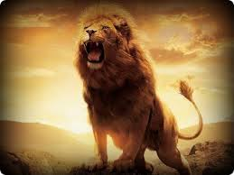

Spiritual Victory

Index

Chapter Page

- The Kingdom of God 3
- The Holy Spirit 8
- The Anointing 10
- The Nature of Spiritual Gifts 13
- Spiritual Gifts 16
- The Ministry of Healing 18
- Healing of Past Hurts 21
- Healing of the Demonised 28
- Guidelines for Casting out Demons 34
Addendum 38

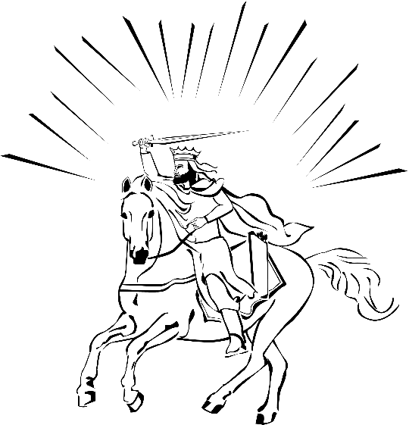

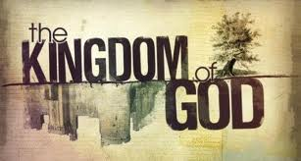
Chapter 1
The Kingdom of God

1. Where do I meet with the Kingdom of God?
- At the New Birth
John 3:3 “... no one can see the Kingdom of God unless he is born
again.”
John 3:5 “I tell you the truth, no one can enter the Kingdom of
God unless he is born of water and the Spirit.”
Col. 1:13 “For He has rescued us from the dominion of darkness
and brought us into the Kingdom of the Son He loves.”

2. What is the Kingdom of God?
There are two aspects to the Kingdom of God.
Present: There is a present reality of the Kingdom that we need to walk in and exercise. This Kingdom is spiritual and is within and among us (Luke 17:20-21; Romans 14:17).

Once having been asked by the Pharisees when the Kingdom of God would come, Jesus replied, “The Kingdom of God does not come with your careful observation, nor will people say, “Here it is,” or “There it is,” because the Kingdom of God is within you.
Luke 17:20-21.

“For the kingdom of God is not a matter of eating and drinking, but of righteousness, peace and joy in the Holy Spirit.”
Romans 14:17

Future: There is also the establishing of the Kingdom of God on
the earth. This is the physical and literal reign of Christ on the
earth (Luke 22:28-30). It is a qualified people, who have continued
with Him (Rev 11:15; 12:1-5; 19:15).
“To him who overcomes and does My will to the end, I will give authority over the nations – “He will rule them with an iron scepter; he will dash them to pieces like pottery” – just as I have received authority from My Father.” Revelations 2:26-27.

“You have made them to be a kingdom and priests to serve our
God, and they will reign on the earth.” Then I looked and heard the
voice of many angels, numbering thousands upon thousands, and
ten thousand times ten thousand. They encircled the throne and
the living creatures and the elders. In a loud voice they were
saying: “Worthy is the Lamb, who was slain, to receive power and
wealth and wisdom and strength and honour and glory and praise!”
Revelations 5:10-12.

3. What makes a Kingdom?
There are four things that constitute a kingdom.

i) You cannot have a kingdom without a king!
No king, no kingdom. The king is the ruler, the sovereign
governing agent.

The early church turned the world upside down. How? They
proclaimed there is another king. Jesus (Acts 17:6,7).
The gospel of the Kingdom (Matt. 24:14) is the proclamation of
the Lordship of the Lord Jesus Christ. It is one thing to know
Him as Saviour, and another to know Him as Lord, King and
Master. The Kingdom of God is not in abeyance. It has not been
postponed as we have been taught. The clock of the Kingdom
has not stopped We are not in a parenthesis. It will yet be
fulfilled and manifested in its entirety in the days to come, but
the Kingdom of God is a present reality, a present truth. Jesus
is King (Luke 10:17-19; 11:20-22).
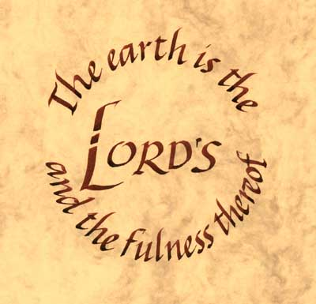
ii) You cannot have a kingdom without a domain.
The domain is territory of the government, the
realm or sphere of His rule (Psalm 24:1). “The
earth is the Lord’s and the fullness thereof, and
all that dwells therein.” The Greek word for kingdom, basileia,”
speaks of a domain, realm or dimension. More specifically, it is
the realm over which the Holy Spirit rules.

“Therefore I tell you that no one who is speaking by the Spirit
of God says, “Jesus be cursed,” and no one can say, “Jesus is
Lord,” except by the Holy Spirit.” 1 Corinthians 12:3.

“Now the Lord is the Spirit, and where the Spirit of the Lord
is, there is freedom. And we, who with unveiled faces all reflect
(or contemplate) the Lord’s glory, are being transformed into
His likeness with ever-increasing glory, which comes from the
Lord, who is the Spirit.” 2 Corinthians 3:17-18.

“Therefore we do not lose heart. Though outwardly we are
wasting away, yet inwardly we are being renewed day by day.
For our light and momentary troubles are achieving for us an
eternal glory that far outweighs them all. So we fix our eyes
not on what is seen, but what is unseen. For what is seen is
temporary; but what is unseen is eternal.”
2 Corinthians 4:16-18.

iii) You cannot have a kingdom without subjects.
Those born in the United Kingdom are called subjects, not
citizens. The reason is that they have a monarchy, a queen or
king (Philippians 3:20). Our conversion (citizenship) is in the
Kingdom of God. Colossians 1:13 - “For he has rescued us from
the dominion of darkness and brought us into the kingdom of
the Son he loves.” We are partakers of the heavenly calling.”
“Therefore, holy brothers, who share in the heavenly calling,
fix your thoughts on Jesus, the apostle and high priest whom
we confess.” Hebrews 3:1.

“But our citizen is in heaven. And we eagerly await a Saviour
from there, the Lord Jesus Christ.” Philippians 3:20.

“Who has saved us and called us to a holy life – not because of
anything we have done but because of His own purpose and
grace. This grace was given us in Christ Jesus before the
beginning of time.” 2 Timothy 1:9.

iv) You cannot have a kingdom without principles.
These are laws that govern the kingdom. Without laws there
would be anarchy and chaos. These principles are designed
both to set us free and to bring us to the place of spiritual
usefulness and abundant life. Sin has bound humanity, but
Jesus sets us free.

“Then you will know the truth, and the truth will set you free.”
John 8:32.

3. The Pattern of Jesus’ ministry (and our’s)
- Proclamation (Mark 16, 1 Cor. 4:20).
The Kingdom of God is not a matter of talk, but of power.
- Demonstration
A call to engage (Luke 9:1,2).
Jesus gave them power and authority to drive out all demons and to cure diseases.

4. Power and Authority
Power is the ability, the might to complete a task.
Authority is the RIGHT to use the power of God. The right comes by belonging to God (being born again), being close to and intimate with Him, by hearing and seeing Him (Matt. 8:8).
Additional Notes

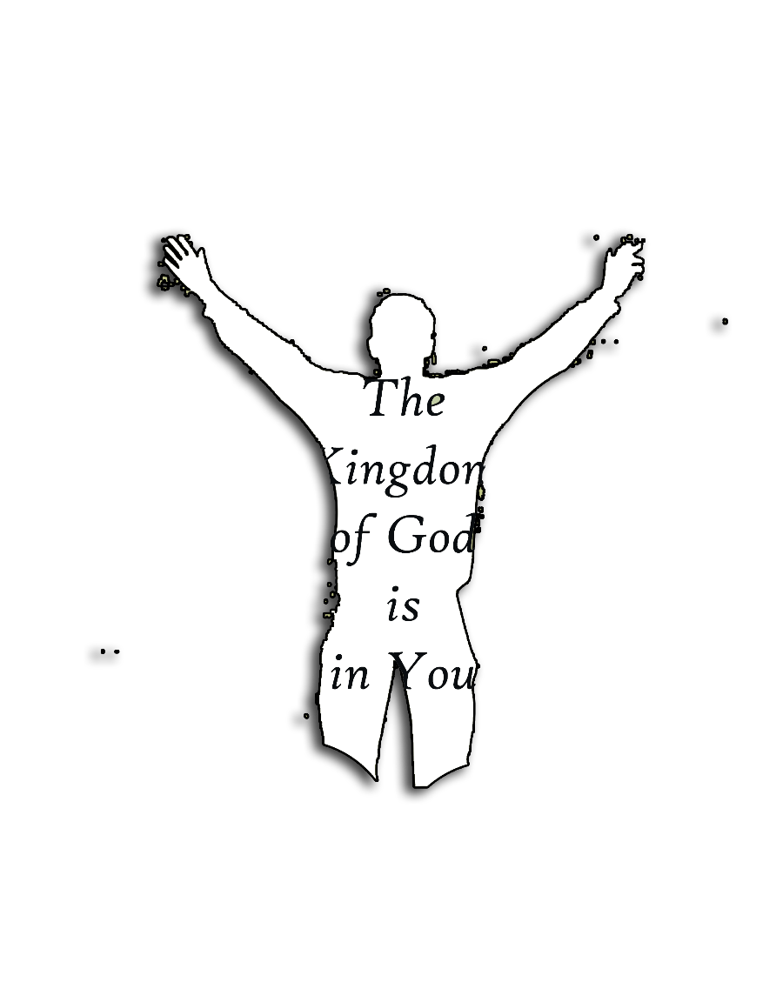


Chapter 2
The Holy Spirit

The Holy Spirit is God

1. He has the attributes of God.
a. Omnipresent - everywhere at the same time [Ps 139:7].
b. Omniscient - all knowing [1 Cor. 2:10,11].
c. Omnipotent - all powerful [Gen. 1:2].

2. He is recognized in Scripture as God. [Acts 5:3-4] - Lying to the Holy Spirit is the same as lying to God.

3. He is a Person and not a force.
a. The Holy Spirit has the characteristics of personality.
i. He is intelligent [1 Cor. 2:10-11].
ii. He has feelings [Eph. 4:30].
iii. He has a will [1 Cor. 12:11].
b. His works are a further proof of His personality.
i. He teaches [John 14:26].
ii. He leads [Rom. 8:14].
iii. He sends [Acts 13:4].
iv. He speaks to men [Acts 8:29].
v. He intercedes [Rom. 8:26].

4. The Holy Spirit regenerates.
i. The Holy Spirit gives new birth to the spirit of
man who is dead in sin [Titus 3:15, John 3:3-7].
ii. He convicts [John 16:8-11].
iii. He baptizes us into the body of Christ
[1 Cor. 12:13].
iv. He seals our salvation [2 Cor. 1:22, Eph. 1:13;
4:30].

5. The indwelling ministry of the Holy Spirit.
a. He fills us with love [Rom. 5:5].
b. He gives us power to be His witnesses [Acts 1:8].
c. He gives power for practical service [Acts 6:1-5].
d. Through us, the Holy Spirit convicts the world of sin, righteousness and judgment [John 16:7-8].
e. He enables us to function in His gifts and to bear the
fruit of the Spirit
f. He wants to continually fill and lead every born again
believer [Eph. 5:18; Rom 8:14].

Additional Notes




Chapter 3

The Anointing

What is the Anointing?
It is the presence and power of God manifested through the Holy Spirit. Often we confuse the Anointing with an experience. However, experiences are the results of the Anointing. The Anointing is Someone; it is a divine Personality; it is the Holy Spirit.

The Anointing Within

At the New Birth every believer receives the indwelling Holy
Spirit. Therefore he has an Anointing that remains within him.
Rom 8:9 says,”...And if anyone does not have the Spirit of Christ, he does not belong to Christ”.
2 Cor 1:21,22: “Now it is God who makes both us and you stand firm in Christ. He anointed us, set his seal of ownership on us, and put his Spirit in our hearts as a deposit, guaranteeing what is to come.”
We don’t have to pray for the Anointing within, when we are born again, we have got it. (Jn 4:14, Jn 14:17, 1 Jn 4:4)

The Anointing Upon
This is a separate experience to having the Spirit dwell within you. At the New Birth the Anointing is God’s blessing IN YOU. The second experience is the baptism in the Holy Spirit, which is the Anointing of the Spirit UPON you. This Anointing makes you a blessing to others and enables you to serve.
It is the power Jesus spoke of in Luke 24:49 “I am going to send you what my Father has promised; but stay in the city until you have been clothed with power from on high” (Acts 1:8, Acts 10:38, Lk 4:18, Zech 4:6).

Anointing on the Ministry Gifts
Eph 4:11 “It was He who gave some to be apostles, some to be prophets, some to be evangelists, and some to be pastors and teachers”.
Jesus functioned in all 5 of the fivefold ministries.
Jn 3:34 says, “For the one whom God has sent speaks the words of God; to him God gives the Spirit without limit”.
(Apostle Heb 3:1; Prophet Lk 4:24; Evangelist Lk 4:18; Pastor (Shepherd) Jn 10:14; Teacher Matt 9:35).
God calls men and women into these offices for different purposes. To function in these offices an Anointing comes upon you, which is the supernatural equipping to get the job done. The Anointing has nothing to do with natural ability, talent, education or lack of education. Jesus said, “ I tell you the truth, the Son can do nothing by Himself; He can do only what he sees His Father doing...” (Jn 5:19). God chose the foolish and the weak things of the world to shame the strong (1 Cor 1:27-29).

Corporate Anointing
The corporate Anointing is the greatest Anointing of all. An O.T. example is found in 2 Chron. 5:11-14. The Temple was literally filled with a cloud of God’s glory. We see in the N.T. that the glory of God is the Spirit of God, (Rom 6:4 & Rom 8:11) which we call the Anointing (Lk 4:18). In the N.T. we also see that the collective church is God’s temple (1 Tim 3:15; 1 Cor 3:16).
What brought about the Anointing in Solomon’s Temple?
- Praise and thanks to God (2 Chron. 5:13).

A N.T. example is Acts 2:46, 47.
Note 3 things in these verses:

They met together (one accord).

Full of gladness.

Praising God.

In Acts 4:23,24 the believers TOGETHER prayed and magnified God and the place was shaken. See also Acts 13:1,2.
There is an Anointing dynamic in united prayer and praise that is much more powerful than the inward Anointing of each believer.

How to Increase the Anointing
Every Christian can have something to do with determining the degree of your Anointing.
1. Prepare yourself for the Anointing through study of the Word and prayer (2 Tim 2:15).
2. Be a worshipper (Acts 2:46,47; Jn 4:23).
3. Follow the ministry of Jesus in the Gospels
(Jn 14:12; cf. 2 Kings 2:1-15).
4. Motive of your heart must be pure (Acts 8:9-20).

Additional Notes



Chapter 4
Nature of Spiritual Gifts

Spiritual Gifts are Supernatural

1. Gifts are bestowed by the Spirit upon Christians only. [1Cor. 12:7] Spiritual gifts are not just human talents.
2. The Bible does not isolate a particular set of gifts as being more supernatural [1Cor. 12:28]. The gifts of healings and tongues are right in the midst of the gifts of helps and administration.

Spiritual Gifts are God’s Spiritual “Gracelets” for His people

1. Spiritual gifts are gifts given graciously to His people. The word for gifts is “charismata” which literally means “gracelets”. It is thus given according to needs and not according to spiritual status. [1 Peter 4:10].

2. Spiritual gifts do not indicate spiritual maturity [1Cor. 1:4-7; 3:1+2; 14:20].

3. Spiritual gifts are tools, not trophies.

Spiritual gifts are situational manifestations of the Holy Spirit

The traditional view maintains that:
1. God has appointed these gifts in the church.
2. Each person does not do the same thing.
3. You already have gifts – you need to discover and develop them – you are to be content and not seek other gifts.

Problems with this view include:

1. Every assembly of Christians is a complete
body of Christ where no gifts are lacking
[1 Cor. 1:7; Col. 2:9,10; Eph. 1:3]
2. Experience shows that gifts are not possessed.
3. There are a number of passages that encourage believers to seek spiritual gifts [1 Cor. 12:31; 14:1,5,12b,13,39].

The interpretive key is found in 12 places in 1 Cor. 11:17-14:40. [11:17, 18, 20, 33, 34; 14:4, 5, 19, 23, 26, 28, 34].

1. Paul is talking about what takes place when the church is assembled.
2. Listings at 1 Cor. 12:8-10 refer to a particular gathering of the church. 1 Cor. 12:29 is a statement about what happens in a meeting.
3. 1 Cor. 14:26 gives a description of a “charismatic” service in which all spiritual gifts are operational.

There must be an understanding between the role, Anointing, ministries and office of Spiritual Gifts.

1. ROLE: The doing of the events, which you see occurring in Scripture – obedience. [Matt. 10:1; 28:18-20, Luke. 9:1,2; 10:1-23; 2Tim. 4:5]
2. GRACELETS/Anointing: The situational manifestation of a gift ordained by God. All can experience every spiritual Anointing as God sovereignly surfaces in them at the point of need [Mk. 16:15; Acts 2:4; 1 Cor. 12:4-6].
3. MINISTRIES: The increase of the occurrence, use and dimensions of the gracelets indicate God’s spiritual calling into a specific ministry.

4. OFFICES: The appointments made by God and given to and recognized by the Church. God takes a person that He is using and gives him/her a functional office [Eph. 4:11,12].

The impact of this view on those who operate in the gifts:

1. All are encouraged to serve boldly and in faith
2. The “gifted” is humbled by the fact that he does not possess the gift.

Spiritual gifts are works of faith and must be encouraged and nurtured:

1. Gifts are imparted and not discovered [1 Tim. 4:14]
2. Gifts are exercised in faith [Rom. 12:6-8] and therefore controllable by the user [1 Cor. 14:32].
3. Gifts must be encouraged and nurtured [1 Cor. 14:1, 12, 39;
2Tim. 1:6].

Spiritual Gifts are given for the common good:

1. They are for edifying [1 Cor. 12:7; 14:4,26].
2. They are to glorify the Lord [1 Pet. 4:10, 11].
3. They are to equip the saints for the ministry [Eph. 4:11, 12]

Additional Notes

Chapter 5
Spiritual Gifts
There are nine Gifts: 1 Cor. 12:8 – 10.
To one is given in and through the Spirit a message of wisdom, and to another a word of knowledge and understanding according to the same Spirit; To another faith by the same Spirit, to another the extraordinary powers of healing by the one Spirit;
To another the working of miracles, to another prophetic insight, to another the ability to discern and distinguish between spirits, to another various kinds of tongues, to another the ability to interpret tongues.

The Eyes of God [Discernment]

1. Word of Wisdom: An utterance inspired by God and spoken by an individual. It reveals a part of the total wisdom of God. It is “seeing” what God sees in a situation and “saying” it. It is applying God’s wisdom to a specific situation.

2. Word of Knowledge: An utterance inspired by God and spoken by an individual. It is an insight into the things “freely given us by God” [1 Cor. 2:12]. It shares the truth of facts, which the Spirit wishes declared concerning a specific occasion, with a practical application of an outpouring of God’s love.


3. Discerning of Spirits: Is the supernatural capacity to judge from a spiritual insight whether the spirit operating has a source that is human, demonic, or divine. It is supernatural perception into the spiritual realm for the purpose of determining the source of the spiritual activity.

The Hand of God [Power]

4. Gift of Faith: Faith is the mysterious surge of confidence, which sometimes arises within a person faced with a specific situation or need. It gives that person a transitional certainty and assurance that God is about to act through a word or action. It is both the irresistible knowledge of God’s intervention at a certain point and the authority to effect this intervention through the power of the Holy Spirit.

5. Effects of Miracles:These are events in which people and things are visibly and beneficially affected in an extraordinary way by the power of God working through an individual.

6. Gifts of Healing:This is the actual event of healing itself, which a sick person receives. As there are many different kinds of illnesses, so there are many different healing gifts.

The Mouth of God [Speech]

7. Prophecy: It is declaring the heart-throb of God to the Church for the purpose of edification. It is not a skill, aptitude or talent. It is the actual speaking forth of words given by the Holy Spirit in a particular situation.

8. Tongues: It is Spirit-inspired speaking in which the conscious mind plays no part. It is the speaking of a language [whether known or angelic] which is unlearned by the speaker.

9. Interpretation of Tongues: This is the God-given inspiration to speak in the language of the listeners, giving to them the dynamic equivalent of that which was spoken in tongues.

Chapter 6
The Ministry of Healing

- We are to minister healing to the sick,
- We believe that it is God’s will that we be healed. [This is so in spite of the fact that many are not healed since “at present we do not see everything subject to Him” – Heb. 2:8b]
- We seek, on our part, to remove all barriers to healing.

A Scriptural Perspective

OLD TESTAMENT

1. The Name of God – “Jehovah Rapha” [Ex. 15:26].
2. The Mosaic Covenant – God’s Salvation includes deliverance
from sickness. [Ex. 23:25-26; Deut. 7:15].
3. The Compassion of God – The forgiveness of sin and the healing
of sicknesses are synonymous works of God. [Ps. 103:2-3].
4. Through the substitutionary work of the Messiah – Christ
carried away our sin and our sicknesses through His death.
[Isa. 53:4-5; Matt. 8:16, 17].

NEW TESTAMENT

- Consider The healing ministry of Jesus Christ.

484 Verses in the 4 Gospels relate specifically to the healing of physical and mental illnesses and the resurrection of the dead.

Purposes of Christ’s healing ministry:

1. Demonstrating Christ’s compassion and
mercy [Matt. 14:14; 20:34; Mark 1:41].

- Bearing witness to the truth of Christ’s claims about Himself [Matt. 8:14-17; Luke 5:18-26].
- Demonstrating that God’s Kingdom has arrived [Matt. 4:23].
- Showing Jesus is the one who was promised by the Father [Matt. 11:1-6].
- Illustrating on the physical plane what God wants to do for us spiritually [Matt. 9:1-8].
- Bringing people to repentance [Luke 10:8-12].
- Showing that the Gospel is intended for the Gentiles as well as the Jews [Luke 7:1-10].

2. Consider the healing ministry of the Apostles and Disciples.

- Christ’s Great Commission to the disciples includes the healing of the sick [Matt. 10:1; Luke 9:1; 10:1, 9, 17; Mark 16:15].
- Healing was the prominent ministry of the New Testament Church [Acts 3:1-10; 6:8; 9:10-19; 9:32-35; 14:8-10; 19:11-12].

3. Consider the healing ministry taught in the Epistles.

- The gifts of healing are part of the spiritual gifts given to the church for ministry [1 Cor. 12:28]
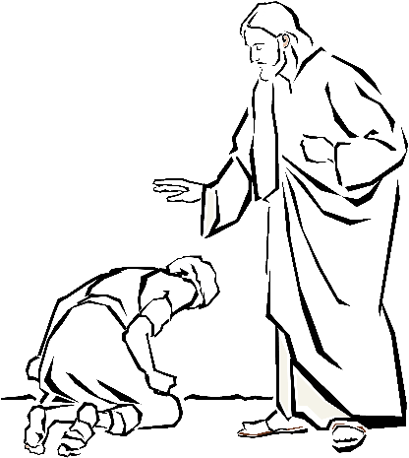
- The ministry of healing is given to the pastors or elders of the church [James 5:13-16].


Why are some not healed?

- We live in a fallen world in which perfect and complete salvation is yet to be experienced [Rom. 8:22, 23; Heb. 2:8].
- The lack of faith in the life of the sick person, the one who is ministering, or the community of believers [Mark 9:17-24; Acts 14:8-10; James 5:15; Mark 6:4-6].
- The presence of sin in the life of the sick person, the one who is ministering or the community of believers [1Cor. 11:30; James 5:15, 16].

Additional Notes

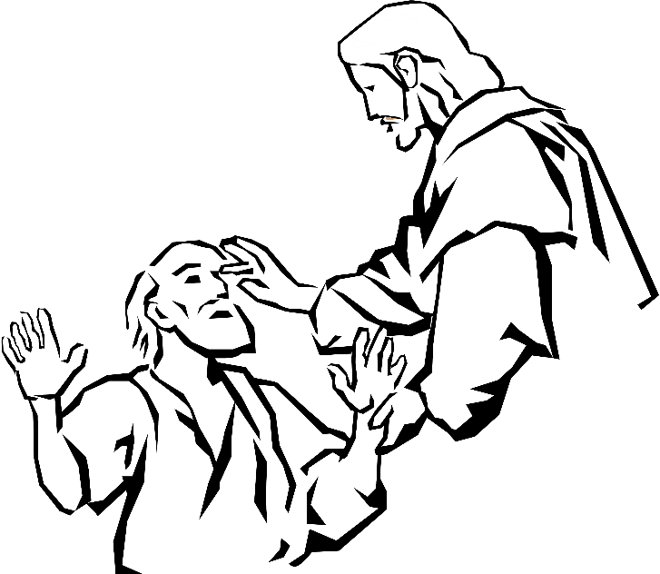

Chapter 7
Healing of Past Hurts

Questions:

1. Is life always fair? _______________________________
2. Why does God allow bad things to happen to us?
_____________________________________________
_____________________________________________
_____________________________________________
Scripture teaches that God is Love.
There are 3 kinds of love: Phileo, Eros and Agape love.
Godly love, or Agape Love is Love that loves because of its own inherent nature - it is spontaneous and automatic.

Because God promises in His Word that we will one day reign with Him in His Kingdom (2 Tim 2:12; Rev 3:21), we are in training for reigning, while on this earth. We can only reign with Him, if we have His Agape Love in our hearts. Suffering produces character, which in turn instils God’s Love in our hearts (Rom 5:3-5).

How do we handle things that happen to us?


Symptoms of Past Hurts:
- depression
- sadness
- anxiety
- fearfulness
- anger
- rebellion
- hatred
- negativity


Walls we Build

Hurting people build walls around themselves in order to protect themselves. Some build walls of rejection, while others build walls of rebellion. Unfortunately these walls tend to become prisons, where people wall themselves in and others out.

Question:

How do I react when I am hurt?
Do I withdraw and build a wall of rejection?
Do I become defensive and build a wall of rebellion?
Am I prepared to forgive unconditionally, even if wrongfully hurt?

Hurts cause:

Sickness of the emotions
While sickness of the spirit is caused by what we do, sickness of the emotions is generally caused by what is done to us. It grows out of the hurts inflicted upon us by another person or some experience we have been exposed to in the past. These hurts affect us in the present, in the form of bad memories, and weak or wounded emotions. This in turn leads us into various forms of sin, depression, a sense of worthlessness and inferiority, unreasoning fears and anxieties, psychosomatic illnesses, etc. Included in this are the present-day effects of the sins of the parents in the bloodline of a person. Thus healing of past hurts touches the emotions, the memories, and the person’s bloodline.

Hurting people hurt others
If we compare our lives with a tree and the “symptoms” we have with the fruit, we see that the tree bears fruit according to the ROOT of the tree. Two most common roots:
- unforgiveness and
- bloodline curses

The Root Cause
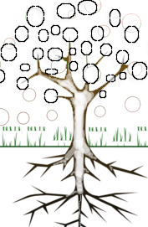
- Sadness
- Self-pity
- Bitterness
- Hatred
- Guilt
- Criticalness
- Discouragement

- Unforgiveness

ROOT

ROOT

The Unforgiving Servant (Matt.18:15-35; 5:23,24)

If we choose not to forgive, we choose to be in the torture chamber - we keep ourselves in bondage!
- Sadness
- Self-pity
- Bitterness
- Hatred
- Guilt
- Criticalness
- Discouragement

- Sins of the parents
(Bloodline curses)

ROOT

Michal (2 Sam.6:12-23 cf. 1 Sam. 18:28-29)

-Saul was jealous of David

-Saul’s jealousy was carried over to his daughter, Michal.

-David married Michal

-Michal despised David when he danced before the Lord because she was jealous of his relationship with the Lord.

A perspective on healing of past hurts

1. Healing of past hurts is valid for the Christian ministry today.

2. We believe that Jesus brought emotional healing to many. “… to bind the broken hearted … to set the prisoners free … to release the oppressed …” [Luke 4:18].

3. Jesus comes to free us from the evil which burdens us. He Who is the same yesterday, today and forever, takes the
memories of our past and heals them along with the wounds
that have resulted from them, and which still affect our
lives in the present.

Peter’s Denial of Jesus[Matt. 26:33-35, 69-75; Mark 14:27-31, 66-72; Luke 22:31-34, 54-62; John 13:36-38; 18:15-18, 25-27; 21:15-22].

-Peter could never accept the fact that Jesus had to die

-the night that Jesus was taken captive, Peter’s faith faltered.

-Consequentailly he denied Jesus 3 times.

-this caused immediate condemnation and depression.

-Peter withdrew and went fishing because of his shame and despair

-After His resurrection Jesus went to Peter where he was fishing

-Jesus asked him 3 times “Do you love me?”

-Jesus recommissioned him “Feed my sheep - this healed him emotionally.

4. Past hurts bring sickness not only to the emotions, but also to every

other aspect of the human personality, and even social relationships.

5. Conversely, the healing of past hurts opens up renewal, not only to

our emotions, but also to every other aspect of human life

affected by it. Jesus takes the memories of our past and heals

them. He also heals wounds that resulted from the hurts we

experienced.

HE MAKES US WHOLE AGAIN!

- The healing of past hurts can take place through:

- Receiving or giving forgiveness [from God and others]. This should break the patterns of habitual responses and behaviour generated in reaction to life’s traumas
[Col. 3:12-17].
- Ask and receive forgiveness (from others if applicable)
- Forgive those that hurt you - unconditionally!
- Walk in forgiveness

Unforgiveness is the opposite of Agape Love

Forgiveness = Agape Love

- Allowing Jesus to reinterpret and heal your bad memories in prayer and conversation through the light of His Word and His purposes [Rom. 8:28].

- Breaking the power of the bloodline if it carries any bad effect from the sins of the parents [through taking authority over it in prayer].

Break the power of the bloodline curse

-Confess

-Ask forgiveness

-Break it in the Name of Jesus

- Breaking any soul-tie or emotional dependence on anyone or anything, that has been the cause of any negative effects. (This is also done through exercising authority in prayer.)

- Renewing the mind on a regular basis into the new identity that we have in Christ [giving us meaning and a sense of worth] through worship, Bible study and meditation
[Rom. 12:1-2].

- Just being part of the body of Christ (and experiencing ongoing growth will bring all sorts of releases in regard to inner healing (Eph. 15,16; James 5:16)

- Because of the nature of this type of sickness amd healing, a loving sensitivity to the person and to the Holy Spirit and His revelatory gifts is necessary. We must be careful of superficiality and yet we must avoid needless and hurtful probing in our dealings. We must avoid excess emotionalism.

- We believe in the use of psychology and other secular practices, only to the extent that they do not contradict Biblical models.

- To keep a healthy, Biblical balance [and avoid a negative and introverted attitude caused by an overemphasis on inner healing] our focus should be on our new nature in Christ. The Biblical depiction of our new nature is surely a truer, more real and trustworthy evaluation than that provided by our own weaknesses, fears, anger, memories, etc. – not to mention the accuser of the brethren! [Rom. 8:1-2, 28,35; Eph. 4:20-24; Rev. 12:11].

- Jesus wants to heal you but are you willing?
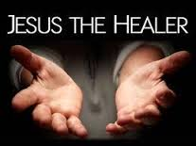

Chapter 8
Healing of the Demonised

Sickness caused by a demonic influence can have all or some of the following symptoms: spiritual, emotional and physical sickness. Healing this type of sickness therefore means the expulsion of that demonic influence and the restoration of all affected areas.

Biblical Case Histories:

- The Gerasene Demoniac [Mark 5:1-20].
- The Child with an Evil Spirit [Mark 9:14-29].
- The Multitudes being healed [Matt. 8:16; Mark 1:32-34; 3:10-13; Luke 4:41; 6:18; Acts 8:7].

A perspective on healing the Demonised

1. Illness caused by a demonic influence affects most aspects of the human being [spiritual, mental, emotional, physical and social].
2. The opposite is also true; the expulsion of the demonic presence or influence leads to the healing of all affected areas.
3. The presence of demons can be discerned through:
- Natural discernment: If the demon manifests itself, you know it is there; or the person may know he/she has a demon; or through conversation you discover the person has a definite pattern of compulsive behaviour [bondage], [e.g. drug addiction, alcoholism, sexual perversion of all kinds, self-destructive thoughts, etc.]
- The gift of distinguishing between spirits to see the real motivation behind things.
- The gift of the Word of Knowledge.
- General spiritual sensitivity and experience; you become aware of the presence of demonic influences; you know the symptoms when you see them.
4. The Greek “diamonizomai” means, “demonised”, which does not define the kind or quality of the illness [i.e. to what extent the demon has influenced or affected the person]. However, the extent to which the person is demonised becomes clear from the nature of the person’s problem.
- “Possession” – If this means “ownership”, then a Christian cannot be possessed since the Christian belongs to God.
- “Affliction” – “oppression” – “bondage” – and “stronghold” are words used to describe demonisation to a lesser extent. This is much more common. This implies varying degrees of demonic influence in certain areas of the person’s life. This can be likened to a military invasion of a city; isolated areas can remain under enemy domination [e.g. physical – a deaf and dumb spirit (Mark 9:25), mental and emotional – spirit of infirmity (1Tim. 4:1) etc.]Christians can be demonised on these levels of influence if they allow themselves to be [1 Cor. 10:20-22; 2 Cor. 10:4, 5; 1 Tim. 4:1-3. See 1 John 5:18, 19 for the security of the believer].
5. We believe that the works of the flesh mentioned by Paul [Gal. 5:19-21; Col. 3:5-9; Eph. 4:25-32] must be dealt with by repentance and self-discipline; but if they are not dealt with, they can eventually become strongholds.
6. Depending on the nature of the problem, confession and repentance of known sin or spiritistic involvement is important for the one receiving healing from demonisation.
7. Demons are expelled in the Name of Jesus [i.e. our authority given by Jesus causes the demons to obey us]. Sometimes demons will challenge our authority.
8. We can command demons to identify themselves, but we must not allow them to hold conversation or to bargain – they should be silenced.
9. We should be aware of all the evasive tactics the demons employ. Therefore operating in teams is always preferable when dealing with demonised people; there is greater authority, insight and power.
10. The person who has been healed from demonisation is not properly whole until support systems [cell groups, caring and counselling, filling of the Holy Spirit] have filled the void in the person’s life [Matt. 12:43-45] and have healed all the other related maladies.
11. We should not adopt the attitude of being “demon seekers” – God should be our preoccupation, and our new nature in Christ our focus. If demons are present, then we should deal with them.
12. Above all, we should always be compassionate when healing the demonised; their dignity should be protected and their physical safety ensured [as far as possible].
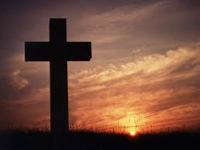
Warfare Prayer

Heavenly Father, I bow in worship and praise before You. I cover myself with the blood of the Lord Jesus Christ as my protection during this time of prayer. I surrender myself completely and unreservedly in every area of my life to You. I do take a stand against all the workings of satan that would hinder me in this time of prayer, and I address myself only to the true and living God and refuse any involvement of satan in my prayer.
Satan, I command you, in the name of the Lord Jesus Christ, to leave
my presence with all your demons, and I bring the blood of the Lord Jesus Christ between us.
Heavenly Father, I worship You, and give You praise. I recognize
that You are worthy to receive all glory, honour and praise. I
renew my allegiance to You and pray that the blessed Holy Spirit
would enable me in this time of prayer. I am thankful, heavenly
Father, that You have loved me from past eternity, that You sent the Lord Jesus Christ into the world to die as my substitute that I would be redeemed. I am thankful that the Lord came as my representative, and that through Him You have completely forgiven me; You have given me eternal life; You have given me the perfect righteousness of the Lord Jesus Christ so I am now justified. I am thankful that in Him you have offered Yourself to me to be my daily help and strength.
Heavenly Father, come and open my eyes that I might see how great You are and how complete Your provision for this new day. I do, in the name of the Lord Jesus Christ, take my place with Christ in the heavenlies with all principalities and powers (powers of darkness and wicked spirits) under my feet. I am thankful that the victory the Lord Jesus Christ won for me on the cross and in His resurrection has been given to me and that I am seated with the Lord in the heavenlies; therefore, I declare that all principalities and powers and all wicked spirits are subject to me in the name of the Lord Jesus Christ.

I am thankful for the armour You have provided, and I put on the girdle of truth, the breastplate of righteousness, the sandals of peace, the helmet of salvation. I lift up the shield of faith against all the fiery darts of the enemy, and take in my hand the sword of the Spirit, the Word of God, and use Your Word against all the forces of evil in my life; and I put on this armour and live and pray in complete dependence upon You, blessed Holy Spirit.

I am grateful, Heavenly Father, that the Lord Jesus Christ spoiled all principalities and powers and made a show of them openly and triumphed over them in Himself. I claim all that victory for my life today. I reject out of my life all the insinuations, the accusations,and the temptations of satan. I affirm that the Word of God is true, and I choose to live today in the light of God's Word. I choose, heavenly Father, to live in obedience to You and in fellowship with Yourself. Open my eyes and show me the areas of my life that would not please You. Work in my life that there be no ground to give satan a foothold against me. Show me any area of weakness Show me any area of my life that I must deal with so that I would please You. I do in every way today stand for You and the ministry of the Holy Spirit in my life.

By faith and in dependence upon You, I put off the old man and stand into all the victory of the crucifixion where the Lord Jesus Christ provided cleansing from the old nature. I put on the new man and stand into all the victory of the resurrection and the provision He has made for me there to live above sin. Therefore, in this day, I put off the old nature with its selfishness and I put on the new nature with its love. I put off the old nature with its fear and I put on the new nature with its courage. I put off the old nature with its weakness and I put on the new nature with its strength. I put off today the old nature with all its deceitful lust and I put on the new nature with all its righteousness and purity.

I do in every way stand into the victory of the ascension and the glorification of the Son of God where all principalities and powers were made subject to Him, and I claim my place in Christ, victorious with him over all the enemies of my soul. Blessed Holy Spirit, I pray that You would fill me. Come into my life, break down every idol and cast out every foe.
I am thankful, heavenly Father, for the expression of Your will for my daily life as You have shown me in Your Word. I therefore claim all the will of God for today. I am thankful that you have blessed me with all spiritual blessings in heavenly places in Christ Jesus. I am thankful that you have begotten me unto a living hope the resurrection of Jesus Christ from the dead. I am thankful that You have made provision so that today I can live filled with the Spirit of God with love and joy and self control in my life, I recognise that this is Your will for me, and I therefore reject and resist all the endeavours of satan and of his demons to rob me of the will of God. I refuse in this day to believe my feelings, I hold up the shield of faith against all the accusations and against all the insinuations that satan would put in my mind. I claim the fullness of the will of God for today.

I do, in the name of the Lord Jesus Christ, completely surrender myself to You, heavenly Father, as a living sacrifice. I choose not to be conformed to this world. I choose to be transformed by the renewing of my mind, and I pray that You would show me Your will and enable me to walk in all the fullness of the will of God today.

I am thankful, heavenly Father, that the weapons of our warfare are not carnal, but mighty through God to the pulling down of strongholds, to the casting down of imaginations and every high thing that exalted itself against the knowledge of God, and to bring every thought into obedience to the Lord Jesus Christ. Therefore in my own life today I tear down the strongholds of satan, and I smash the plans of satan that have been formed against me. I tear down the strongholds of satan against my mind, and I surrender my mind to You, blessed Holy Spirit. I affirm, heavenly Father, that You have not given us the spirit of fear, but of power, love and a sound mind. I break and smash the strongholds of satan formed against my emotions today, and I give my emotions to You. I smash the strongholds of satan against my body today, and I give my body to You, recognising that I am Your temple; and I rejoice in Your mercy and Your goodness. Amen.

Chapter 9
Guidelines For Casting Out Demons

Minister in Love
When you encounter a person suspected of being demonised, assure that person of your concern and care. If that person is fearful and does not trust you, he will not co-operate and deliverance may be unfruitful. DO NOT do deliverance if that person does not want to be delivered.

Share the Gospel
If the person is not a Christian, share the Gospel with that person and lead him to the Lord before you carry out deliverance.

If the person is a Christian, ask him to re-dedicate his life to the Lord. Do not assume that the person is a Christian because he says so. Always check with him as to when he became born again, unless you are sure that he is a Christian.

Requirements for Deliverance
1. Be humble, desire deliverance [1 Pet. 5:6]
2. Be totally open and honest, acknowledge and call the demon by its name [Ps. 32:1-5].
3. Confess and renounce the sin of your family line.
4. Confess and renounce your own sin (occult) [James 5:16].
5. Repent, turn around, break the bondage of Satan [Isa. 55:7].
6. Choose to forgive everyone (resentment) [Heb. 12:15].
7. Call on the Name of the Lord [Joel 2:32; Rom. 10:13] and commit the totality of your life to His Lordship.
8. Speak out against Satan and his demons.

Preparation for Deliverance

1. Pray together.

2. The person must confess all known sin.

3. The person must renounce all evil [occult] involvement.

Deliverance

1. Where possible, carry out deliverance in private, i.e. not in a public place. Ask non-Christians to leave.
2. Do not do deliverance alone – two or more persons should do it. Jesus sent His disciples out in two’s [Luke 10:1].
3. Inform the demonised person of the right to exercise his will – the demon may be in him, but cannot control his will. Ask him to speak to the demon and command him to leave – without this co-operation deliverance may not take place.
4. Maintain eye contact with the person all the time [Luke 11:34].
5. DO NOT ENGAGE IN UNNECESSARY CONVERSATION with a demon. Very often the demon simply wants to waste time so that it can escape being cast out. However, you may ask the demon for its name [Luke 8:30].
6. Cast the demon out IN THE NAME OF JESUS CHRIST. Some people command the demon to go to the Abyss – [Luke 8:31; Mark 9:25].
7. It is not necessary to scream at the top of your voice – it may cause the demonised person to be frightened.
8. Do not allow the demons to manifest in ways that will humiliate
the demonized – simply take authority in the Name of Jesus, e.g.
“In Jesus’ Name, I command you to keep quiet.” [See Mark 1:25].

Warfare prayer for a friend who shows symptoms of possible demonic bondage.

Heavenly Father, I bring before You and the Lord Jesus Christ my dear brother/sister (name). I have come to see that satan is blinding and binding him in awful bondage. He is in such a condition that he cannot or will not come to You for help on his own. I stand in for him in intercessory prayer before Your throne. I draw upon the person of the Holy Spirit that He may guide me to pray in wisdom, power and understanding.

In the name of the Lord Jesus Christ, I loose (name) from the awful bondage the powers of darkness set on destroying his life. I bind them aside in the name of the Lord Jesus Christ and forbid them to work. I bind up all powers of depression that are seeking to cut (name) off and imprison him in a tomb of despondency. I bring in prayer the focus of the Person and work of the Lord directly upon (name) to his strengthening and help. I bring the mighty power of my Lord's incarnation, crucifixion, resurrection, ascension and glorification directly against all forces of darkness seeking to destroy (name). I ask the Holy Spirit to apply all of the mighty work of the Lord Jesus Christ directly against all forces of darkness seeking to destroy (name).

I pray, Heavenly Father, that You nay open (name)'s eyes of understanding. Remove all blindness and spiritual deafness from his heart. As a priest of God in (name)'s life, I plead Your mercy over his sins of failure and rebellion. I claim all of his life united together in obedient love and service to the Lord Jesus Christ. May the Spirit of the Living God focus His mighty work upon (name) to grant him repentance and to set him completely free from all that binds him.

In the name of the Lord Jesus Christ, I thank You for Your answer. Grant me the grace to be persistent and faithful in my intercessions for (name), that You may be glorified through his deliverance, Amen.


Requirements to stay free

1. Live in the Word [James 1:21; Col. 3:16].
2. Continually praise and worship God.
3. Guard your thoughts [2 Cor. 10:5].
4. Cultivate the right relationships – watch out for hatred, resentment and offence – be quick to forgive.
5. Submit to spiritual authority. Join a church and a home cell

Sometimes Deliverance is unsuccessful for one or more of the following reasons:

1. The person may be unable to forgive himself, or others.
2. The person may be angry with God.
3. The person may not be co-operative by not exercising his will.
4. There may still be unconfessed sins.

Follow-up

Follow-up of the person is necessary to make sure that he does not come under demonic attack. You need to keep in touch with that person for the next few weeks or so just to make sure that everything is all right.

ADDENDUM:
NON-CHRISTIAN SPIRITUAL EXPERIENCE INVENTORY

OCCULT

- Astral-projection
- Ouija board
- Spirit Medium
-god inquiry
- Table or body lifting
- Dungeons and Dragons
- Speaking in Trance
- Automatic Writing
- Magic eight ball
- Telepathy
- Using spells or curses
- Séance
- Materialization
- Clairvoyance
- Ghost / Spirit guides
- Fortune telling
- Tarot cards
- Divination
-Stick divination
- Palm reading
- Face reading
- Astrology / Horoscopes
- Rod & pendulum (dowsing)
- Self-hypnosis

- Mental manipulations or attempts to swap minds
- Black and white magic
- New Age medicine
- Blood pacts or cutting yourself in a destructive way
- Fetishism (objects of worship, crystals, good luck charms)
- Incubi and succubi (sexual spirit)
- Chanting of spells
- Charm writing
- Amulets
- Sorcery
- Demon Craft
- Geomancy
- Numerology
- Witchcraft
- Spirit healing
- Spiritism



Any Questions????

